## Section 10 - Ceramic Rotary Engine

### 10.1 - Ceramic Rotary Engines Incorporated (CRE)

This organisation established around the early 2010s (2013 estimated) have been developing rotary engine designs used advanced ceramics for the major components  within the engine.

[Summary of Team](http://www.creinc.us/?page_id=102)

**Advantages:**

* Ceramics allow for the engine to run hotter.
* Thus running more efficiently.
* Able to endure higher RPM's within application.
* Operate on various fuel types for burning.

Low combustion efficiency - low operating temperatures from high thermal conductivity (of metals) results in limitations to the life of **metal engines** because of their metal components. In contrast, CRE claims that the ceramic materials minimize all of these mentioned shortcomings of the metal rotary engine.

The following is one of the earliest videos on the CRE design:

[Video Source](https://www.youtube.com/watch?v=YnfFEf7wyww)

### 10.2 - Ceramic Material Selection

The company itself has defined the most ideal ceramic material for the components is '**ceria - stabilized zirconia**'. The company had claimed to have tested ceramic materials inclusive of silicon nitride, silicon carbide, alumina and zirconia.

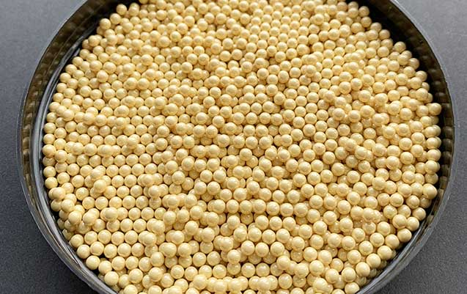

Figure 1 - Ceria - Stabilized Zirconia Beads

[*Image Source*](https://shinysmooth.com/ceria-stablized-zirconia-beads)

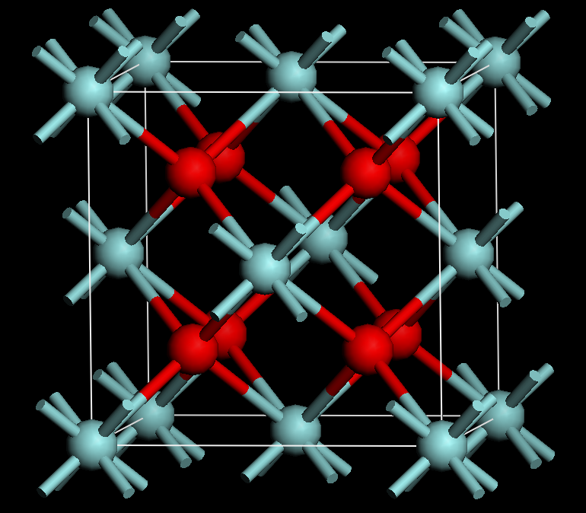

Figure 2 - Fluorite-like Crystal Structure of Ceria and Cubic Zirconia

[*Image Source*](https://en.wikipedia.org/wiki/Ceria-zirconia)

**Advantages:**

* High fracture toughness.
* Bend strength.
* High temperature capability.
* Low thermal conductivity.
* Resistance to hydrothermal degradation.
* Oxidation in the presence of a variety of chemically active fuel materials and additives.

(Ceramic Rotary Engines, Inc, 2013)

### 10.3 - Overall Engineering Impact & Applications

With reference to the claims of the company, the ceramic component will save roughly around 30% of heat the typical internal combustion engine loses.

The company states that this opens up some interesting possibilities for the applications of the design within decentralised heating and electrical applications. This would include small generators and engines producing >0.5 kW - replacement for battery applications.

**Attributes of the CRE Engine:**

* High Power Density Engine
  + Smooth - Two Moving Parts
* High Temperature Operation
  + Leading to Higher Fuel Efficiency
* Multi-Fuel Capability
  + Burns away majority-all Hydrocarbon Fuels
* Cleaner Emission
  + More Complete Fuel Combustion
* Little Heat Loss
* No Water-Cooling System
  + No Requirements for:
    - Water Jacket,
    - Hose,
    - Radiator

(Ceramic Rotary Engines, Inc, 2013)

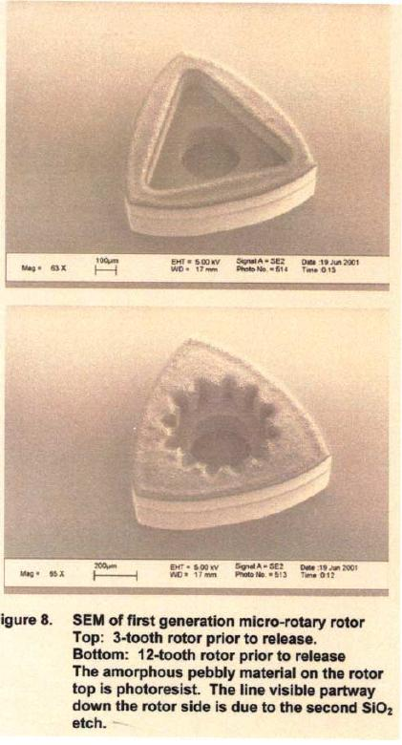

Figure 3 - A Silicon MEMS Micro Rotary Engine Rotor

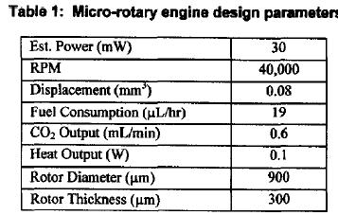

Figure 4 - Results of Testing Figure 1

[*Images Source*](https://www.rx8club.com/series-i-tech-garage-22/ceramic-rotary-engine-2384/)

### 10.4 - Disadvantages

The major disadvantage of the design is the cost. The ability to employ such an engine into a vehicle or for similar purposes of conventional metal rotary engines would cause a spike in expense. It would potentially be applicable into an industry such as Formula One however, that would bring upon its own competitors and issues. The average consumer market would not be able to employ such a design as the ceramic rotary engine into spots, coupes or sedan markets. Hence, why most applications are on smaller battery or engine operations.

Furthermore, ceramic is heavy and may increase in comparison to the weight of a conventional steel rotors and housing components within an engine.

### 10.5 - Societal Impact

The organisation further states that due to high temperatures of operation, the engine would be open to running on renewable fuels. Through research of various fuels, this could include renewable fuels from cellulosic bioethanol to vegetable oils, the diversity in fuel options for such material is near endless.

In future developments, this organisation specifically, aims to create engines in applications of water pumping and electricity generation for applications in lighting and cooking. Such applications would impact undeveloped regions of the world and reduce the necessity for firewood. Hence, minimising the reliance on the environment in some applications.

You can visit their older website, summarising their projects and development below:

[Website - CRE Inc.](http://www.creinc.us/)

Ceramic Rotary Engines, Inc is Incorporated in the State of Texas, USA

**References:**

[1] - Destefani, J., 2013. *Rotary engine materials, applications reimagined | The American Ceramic Society*. [online] The American Ceramic Society. Available at: <https://ceramics.org/ceramic-tech-today/rotary-engine-materials-applications-reimagined> [Accessed 30 May 2021].

[2] - RX8Club.com. 2003. *Ceramic Rotary Engine - RX8Club.com*. [online] Available at: <https://www.rx8club.com/series-i-tech-garage-22/ceramic-rotary-engine-2384/> [Accessed 30 May 2021].

[3] - Creinc.us. 2013. *Ceramic Rotary Engines, Inc*. [online] Available at: <http://www.creinc.us/> [Accessed 30 May 2021].